17th , Mar, 2026
Lab Assignment No: - 02
Understanding Stereo Vision and
Epipolar Geometry

Submitted By: Shafi Azam
Registration No: SP24-BAI-047
Submitted To: Mam Maheen Gul
Subject: CV


Department of Computer Science
Comsats University Islamabad
Islamabad Campus

LAB: 06
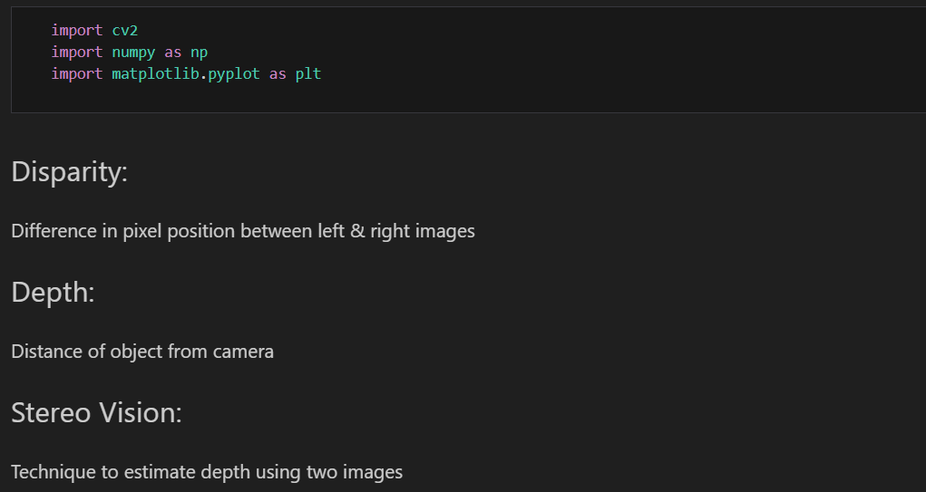
ACTIVITIES
Activity 01: Load Stereo Images
#load the left and right grey images
img_left = cv2.imread('"D:\\Semester 5\\Computer Vision\\Lab\\Lab 6\\Il.jpg.jpeg"', cv2.IMREAD_GRAYSCALE)
img_right = cv2.imread('"D:\\Semester 5\\Computer Vision\\Lab\\Lab 6\\Ir.jpg.jpeg"', cv2.IMREAD_GRAYSCALE)

plt.figure(figsize=(10, 4))

plt.subplot(1, 2, 1)
plt.imshow(img_left, cmap='gray')
plt.title('Left Image')

plt.subplot(1, 2, 2)
plt.imshow(img_right, cmap='gray')
plt.title('Right Image')

plt.show()

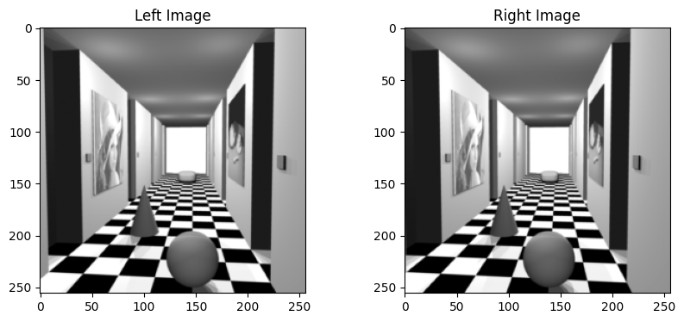
Activity 02: Compute Disparity Using Sum of Square Differences (SSD)
def compute_ssd_disparity(left, right, window_size=3, max_disp=64):
h, w = left.shape
disparity = np.zeros((h, w))

offset = window_size // 2

for y in range(offset, h-offset):
for x in range(offset, w-offset):
min_ssd = float('inf')
best_disp = 0

for d in range(max_disp):
if x - d - offset < 0:
continue

ssd = 0
for wy in range(-offset, offset+1):
for wx in range(-offset, offset+1):
diff = int(left[y+wy, x+wx]) - int(right[y+wy, x+wx-d])
ssd += diff * diff

if ssd < min_ssd:
min_ssd = ssd
best_disp = d

disparity[y, x] = best_disp

return disparity

disp_3 = compute_ssd_disparity(img_left, img_right, window_size=3)

plt.imshow(disp_3, cmap='gray')
plt.title("Disparity Map (3x3)")
plt.colorbar()
plt.show()
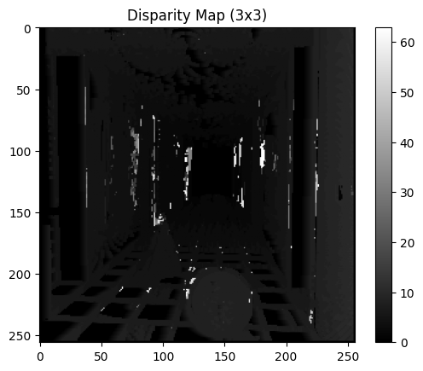

disp_20 = compute_ssd_disparity(img_left, img_right, window_size=20)

plt.imshow(disp_20, cmap='gray')
plt.title("Disparity Map (20x20)")
plt.colorbar()
plt.show()

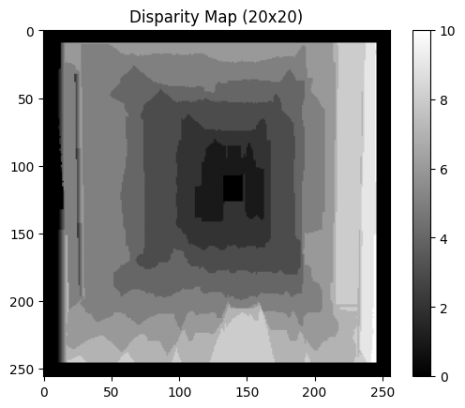

Activity 3: Compute Disparity Map Using Formula
def compute_depth(disparity, B=0.54, f=721):
depth = np.zeros_like(disparity)

for i in range(disparity.shape[0]):
for j in range(disparity.shape[1]):
if disparity[i,j] > 0:
depth[i,j] = (B * f) / disparity[i,j]
else:
depth[i,j] = 0

return depth

depth_map = compute_depth(disp_20)

plt.imshow(depth_map, cmap='jet')
plt.title("Depth Map")
plt.colorbar()
plt.show()

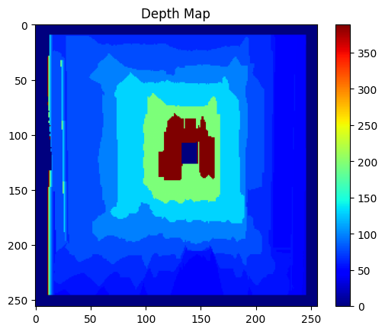

Activity 4: Build Depth Map
# Normalize for display
depth_normalized = cv2.normalize(depth_map, None, 0, 255, cv2.NORM_MINMAX)
depth_normalized = np.uint8(depth_normalized)

plt.imshow(depth_normalized, cmap='jet')
plt.title("Normalized Depth Map")
plt.colorbar()
plt.show()
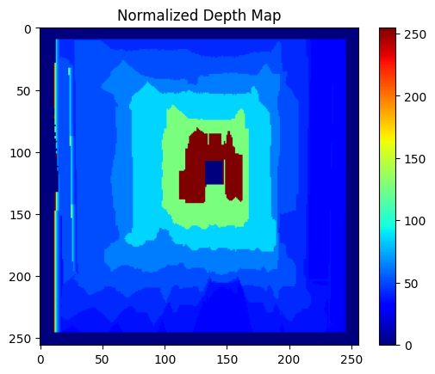

# Compare Disparity vs Depth
plt.figure(figsize=(12,5))

plt.subplot(1,2,1)
plt.imshow(disp_3, cmap='gray')
plt.title("Disparity Map")

plt.subplot(1,2,2)
plt.imshow(depth_normalized, cmap='jet')
plt.title("Depth Map")
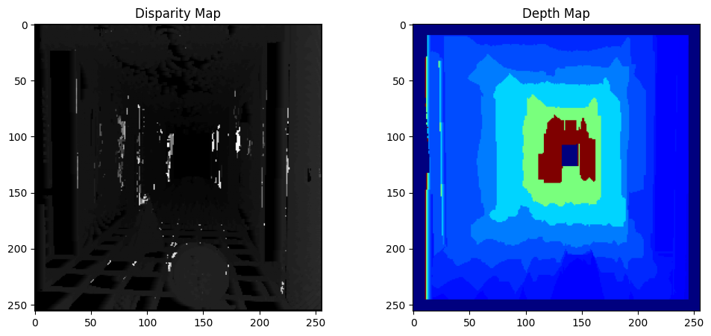
plt.show()

# Using OpenCV (Better Result)
stereo = cv2.StereoBM_create(numDisparities=64, blockSize=15)
disp_cv = stereo.compute(img_left, img_right)

plt.imshow(disp_cv, cmap='gray')
plt.title("OpenCV Disparity")
plt.colorbar()
plt.show()

# Using OpenCV (Better Result)
stereo = cv2.StereoBM_create(numDisparities=64, blockSize=15)
disp_cv = stereo.compute(img_left, img_right)

plt.imshow(disp_cv, cmap='gray')
plt.title("OpenCV Disparity")
plt.colorbar()
plt.show()
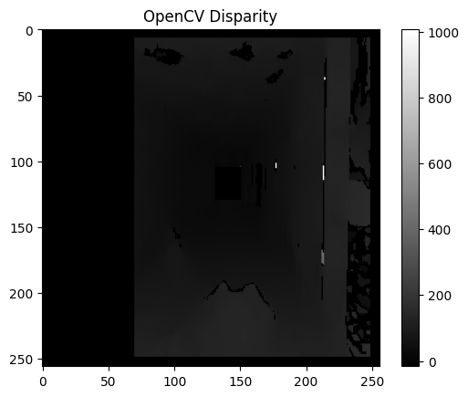

TASKS
Task: 01
1. Objects closer than threshold are considered obstacles.
2. Depth map is thresholded to detect obstacles.
3. Bounding boxes are drawn around detected regions.
# detect obstacles

threshold = 2.0

obstacle_mask = depth_map < threshold

plt.imshow(obstacle_mask, cmap='gray')
plt.title("Obstacle Detection (Corridor)")
plt.show()
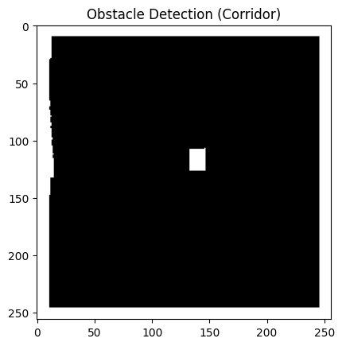

# highlight obstacles on the original image

mask = np.uint8(obstacle_mask * 255)

contours, _ = cv2.findContours(mask, cv2.RETR_EXTERNAL, cv2.CHAIN_APPROX_SIMPLE)

img_color = cv2.cvtColor(img_left, cv2.COLOR_GRAY2BGR)

for cnt in contours:
x, y, w, h = cv2.boundingRect(cnt)
cv2.rectangle(img_color, (x,y), (x+w, y+h), (0,0,255), 2)

plt.imshow(cv2.cvtColor(img_color, cv2.COLOR_BGR2RGB))
plt.title("Detected Obstacles")
plt.show()
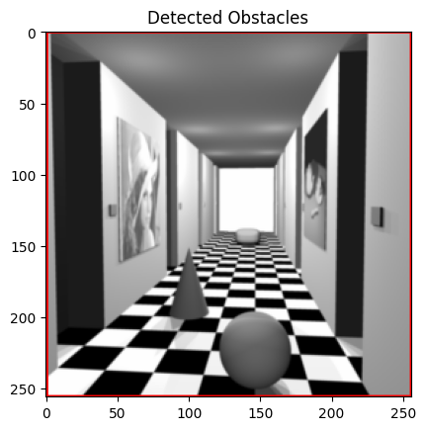

Task 2: Augmented Reality (AR Placement)
1. Depth map is used to estimate object distance.
2. Virtual object is placed at selected pixel.
3. Distance is displayed using depth formula.
# Choose a pixel (center)
h, w = depth_map.shape
x, y = w//2, h//2

distance = depth_map[y, x]

img_ar = cv2.cvtColor(img_left, cv2.COLOR_GRAY2BGR)

cv2.circle(img_ar, (x,y), 20, (0,255,0), -1)

cv2.putText(img_ar, f"{distance:.2f}m", (x, y-10),
cv2.FONT_HERSHEY_SIMPLEX, 0.6, (0,0,255), 2)

plt.imshow(cv2.cvtColor(img_ar, cv2.COLOR_BGR2RGB))
plt.title("AR Object Placement")
plt.show()
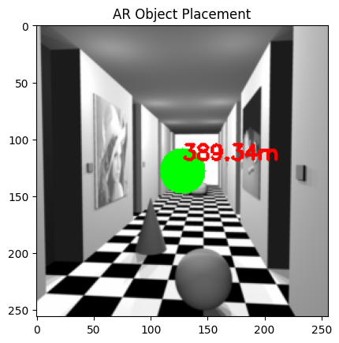
Task 3: Traffic Monitoring (Vehicle Distance)
1. Depth map is used to estimate vehicle distance.
2. Regions are detected using thresholding.
3. Distance is calculated using median depth.

# Assume vehicles are within certain distance
mask = (depth_map > 0) & (depth_map < 20)

mask = np.uint8(mask * 255)

contours, _ = cv2.findContours(mask, cv2.RETR_EXTERNAL, cv2.CHAIN_APPROX_SIMPLE)

img_traffic = cv2.cvtColor(img_left, cv2.COLOR_GRAY2BGR)

for cnt in contours:
area = cv2.contourArea(cnt)

if area > 500:
x, y, w, h = cv2.boundingRect(cnt)

region = depth_map[y:y+h, x:x+w]
distance = np.median(region)

cv2.rectangle(img_traffic, (x,y), (x+w,y+h), (255,0,0), 2)
cv2.putText(img_traffic, f"{distance:.2f}m", (x,y-5),
cv2.FONT_HERSHEY_SIMPLEX, 0.5, (0,255,255), 2)

plt.imshow(cv2.cvtColor(img_traffic, cv2.COLOR_BGR2RGB))
plt.title("Traffic Monitoring")
plt.show()
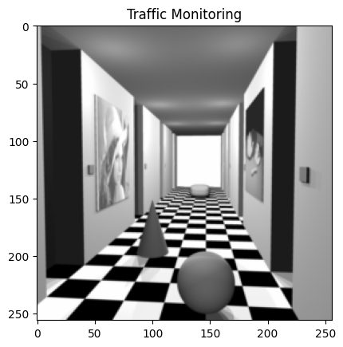
Task 4: Medical Imaging (Stereo Depth)
1. Depth map helps visualize internal structures.
2. Close regions represent important tissues.
3. Useful in surgical navigation and diagnosis.
# Normalize depth for visualization
depth_norm = cv2.normalize(depth_map, None, 0, 255, cv2.NORM_MINMAX)
depth_norm = np.uint8(depth_norm)

plt.imshow(depth_norm, cmap='jet')
plt.title("Medical Depth Visualization")
plt.colorbar()
plt.show()

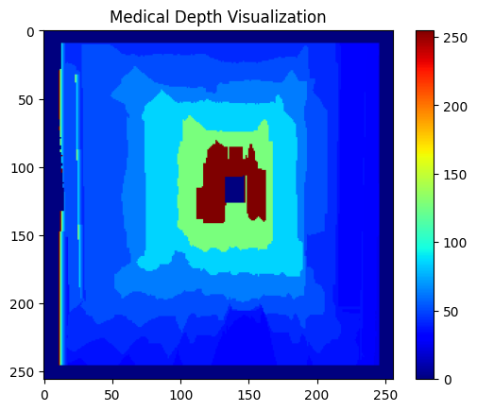
# Highlight very close regions (like tissues)

mask = depth_map < 0.5

plt.imshow(mask, cmap='gray')
plt.title("Close Tissue Regions")
plt.show()
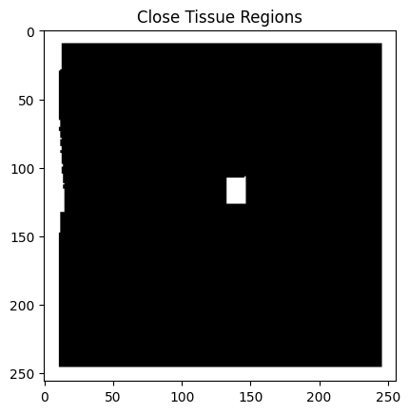

FINAL CONCLUSION
1. Stereo vision is used to estimate depth from two images
2. Disparity is inversely proportional to depth
3. Larger disparity → closer object
4. Depth maps enable real-world applications:
1. Obstacle detection
2. AR systems
3. Traffic monitoring
4. Medical imaging

